HRANIPEX ARTICLE – checking availabilty

This function shows us availability of all our products.

All products are clasified into Product Groups which is necessary to know for better understanding.
E.g.
ABS from PG 1010 we slit from JRs from 1210.
Melamines from 2220 we slit from JRs from 2020.

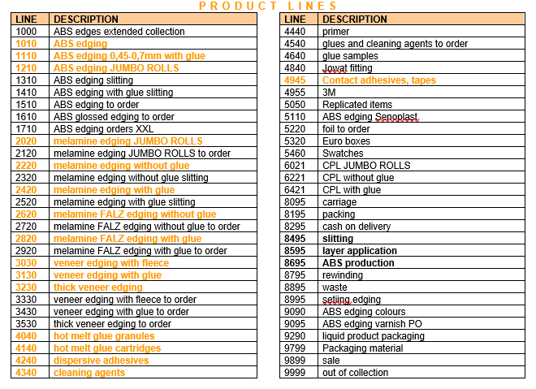

Customer is ordering as below = 600m 284886X30023200 (ABS Walnut Pore in 23x2mm).

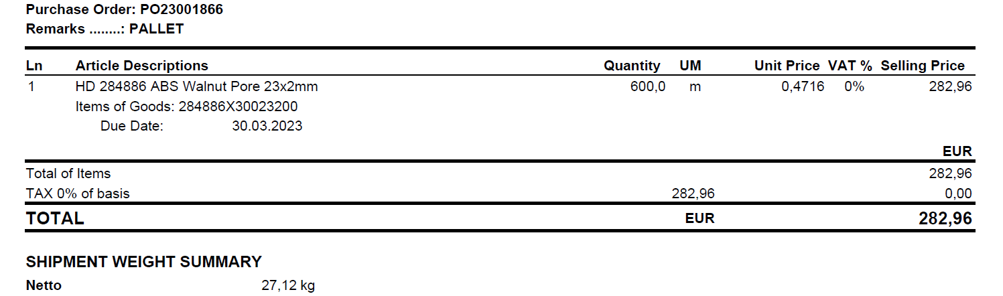

We see that we do not have enough Qties in our stock.
We need 600m and there is just 134m in the shelf (location 104-34-02) in our warehouse.

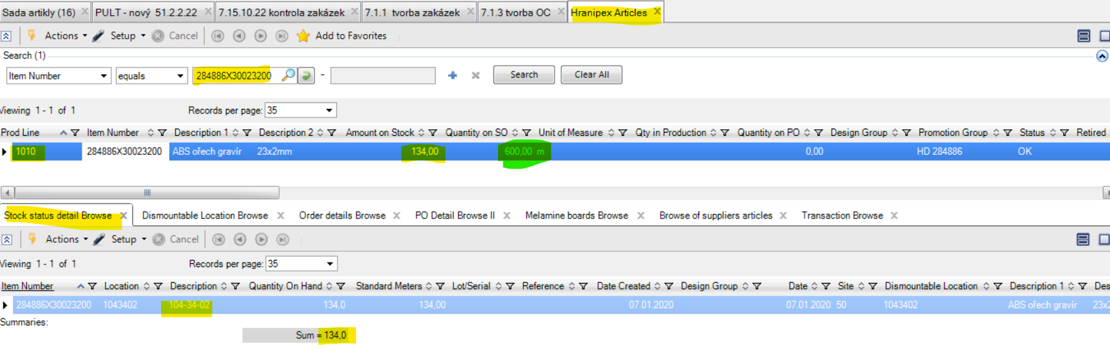

Then we have to check availability of JRs from PG 1210 in our stock.
Kindly note that each category as ABS (PG 1210) and melamines (PG 2020) have their own Product Group.
There is 43,77m2 in total.

There are 2 JRs:

1. line = reference 19120618, JR with 61,06m length (it is shorter length, has been already rewinded)

2. line = reference 22090251, JR with 100m length (full length for 2mm thickness) and this JR has width 340mm
Let´s slit 23mm edge from this JR. We have to also count with -6mm for a waste of ABS (for melamines we need – 12mm).

360mm (JR width) – 6mm (waste) : 23mm (edge width) = 15,39 (mean we can slit 15x 100m rolls from this JR). Which is sufficient because we only need 6x 100m rolls. We need + 1 working day for slitting, so we can confirm the order with Due Date + 1 day to our client.

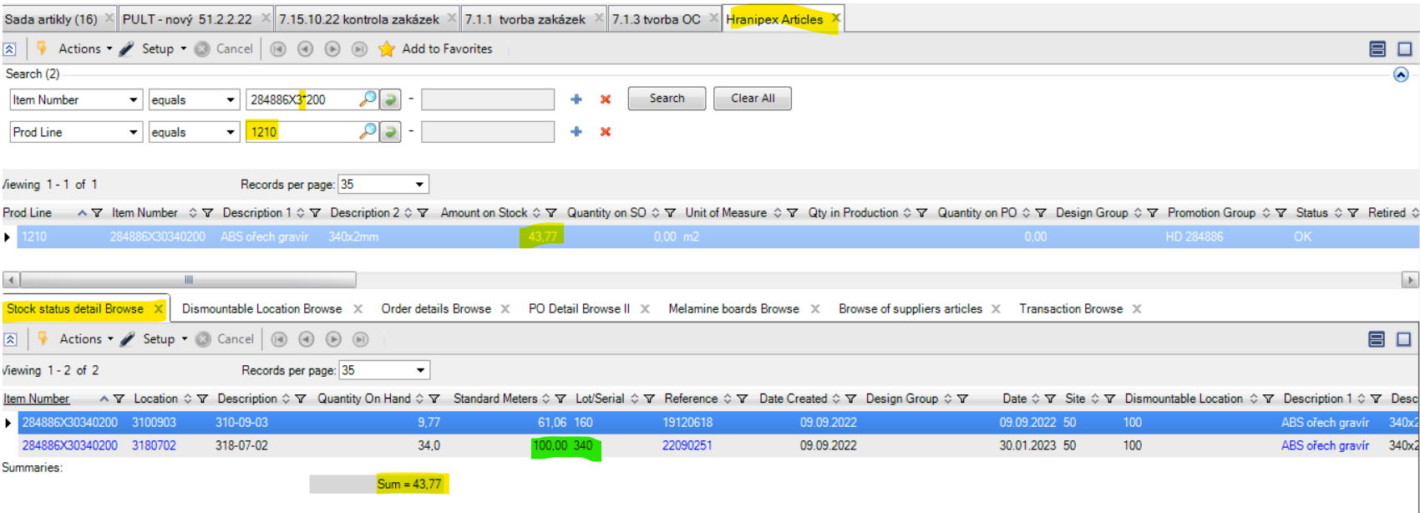

Kindly note that we can count/combine slitting from several JRs.
Some customers also take shorter rolls. We usually offer shorter rolls when we do not have full rolls of JRs in our stock.
Means that we can offer them to get 284886X30023200 also in 61m length from JR reference 19120618.

